What is participatory mapping?

Participatory mapping is an interactive approach that draws on local people’s knowledge, enabling participants to create visual and non-visual data to explore social problems, opportunities and questions. Participants work together to create a visual representation of a place. At the same time, while creating their map, the group may discuss how to best represent the place, share their observations as they
go along, and tell personal stories. This can lead to rich and sometimes surprising data for social research.

One of the strengths of participatory mapping as a research method is that it allows different features to be explored at the same time. Physical and social geography, changes that have occurred over time, residents’ personal and collective experiences, and their attitudes and perspectives on their environment are just a few of the subjects that can be explored through a mapping exercise. The approach recognizes local people as capable research collaborators, and it empowers them in that it helps participants define and represent places and relationships that are important to them.

Adapted from Pathways through participation
http://pathwaysthroughparticipation.org.uk/wp-content/uploads/2009/09/Using-participatory-mapping-to-explore-participation-in-three-communities_June-2010.pdf

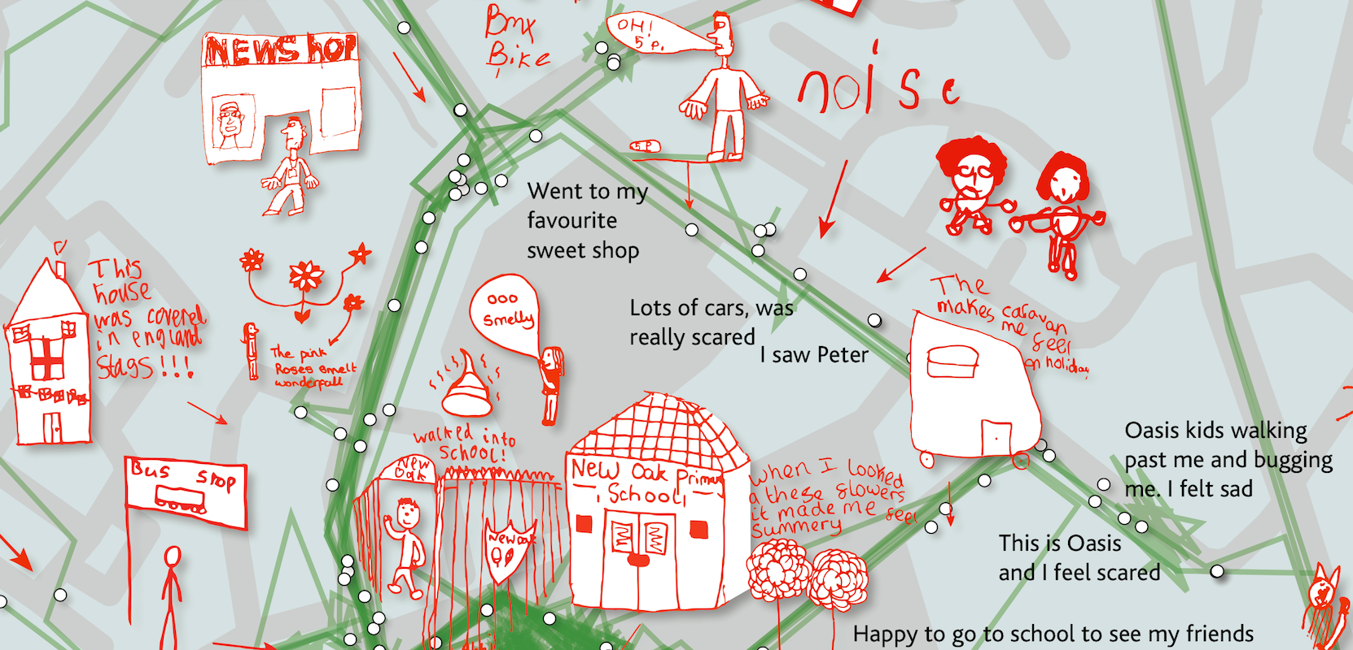

http://wikimaps.wikimedia.fi/2014/02/01/a-travelogue/

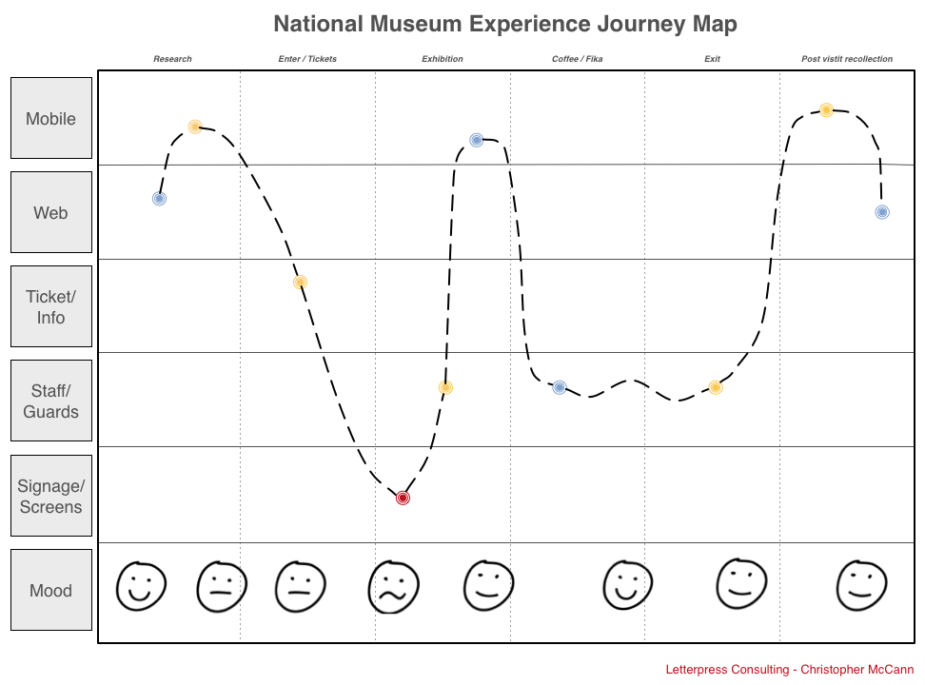

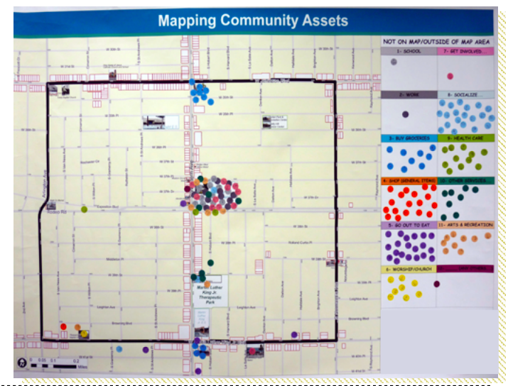
+ Revolutionizing Education: p. 54 & 57
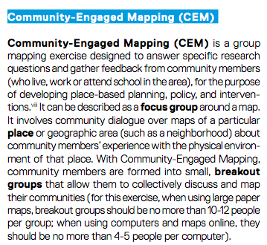

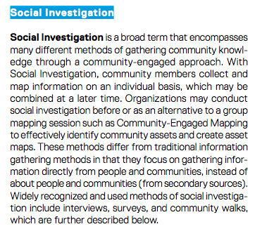

from Healthy City
http://communityscience.com/knowledge4equity/AssetMappingToolkit.pdf

