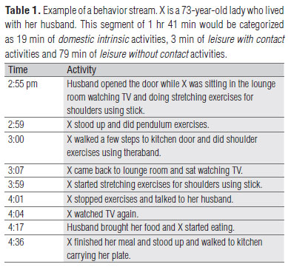

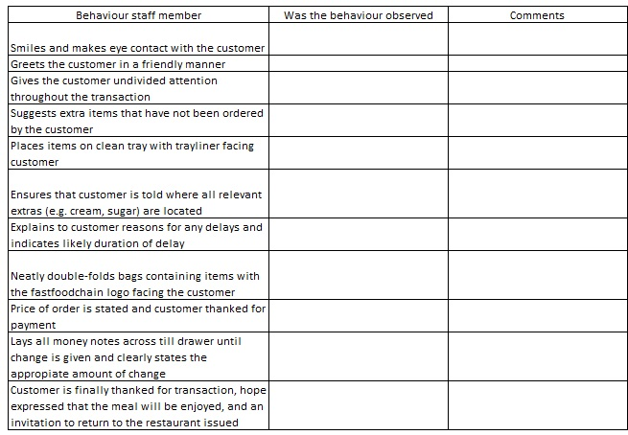
How does one know what to observe?
- sort out the regular from the irregular activities
- look for variation to view the event in its entirety from a variety of viewpoints
- look for the negative cases or exceptions
- when people behave in a way that’s related to your study, try to find similar opportunities for observation and plan regular observations of those events/behaviors

How does one go about conducting observation?
- Descriptive observation: observe anything and everything, assume that you know nothing (the disadvantage of this type is that it can lead to the collection of minor details that may or may not be relevant to the study)
- Focused observation: observation supported by interviews, participants' thoughts/ideas from interviews guide decisions about what to observe
- Selective observation: focus on different types of activities to help describe the differences in those activities
Another approach:
- Develop an observation guide including elements you want to record (e.g. physical environment (e.g. surroundings), describe participants in detail, record the activities and interactions that occur, look at how often & for how long those activities/interactions happen)
- When observing conversation: write content (what they say), who speaks to whom, who listens, who silences others, the researcher's own behavior and how that role affects those one is observing, what the researcher says or thinks.

Adapted from FQS
http://www.qualitative-research.net/index.php/fqs/article/view/466/996#g7

