Survey Example

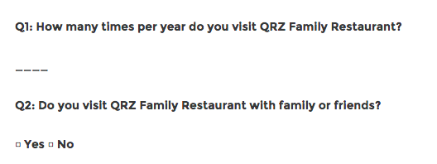

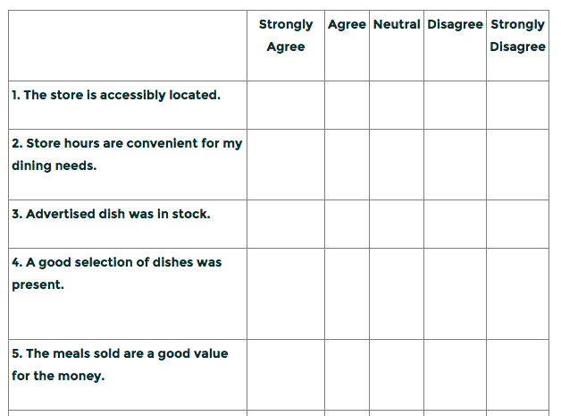

Surveys - brief interviews and discussions with individuals about a specific topic. Yes, survey is also a specific type of survey, to make things even more confusing. A survey is a quick interview, with the surveyor asking only a few questions.
http://study.com/academy/lesson/what-is-survey-research-definition-methods-types.html

Open-ended vs. Closed-ended Questions
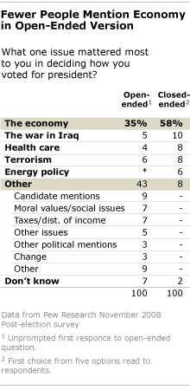
All researchers must make two basic decisions when designing a survey--they must decide: 1) whether they are going to employ an oral, written, or electronic method, and 2) whether they are going to choose questions that are open or close-ended.
Closed-Ended Questions: Closed-ended questions limit respondents' answers to the survey. The participants are allowed to choose from either a pre-existing set of answers, such as yes/no, true/false, or multiple choice with an option for "other" to be filled in, or ranking scale response options. The most common of the ranking scale questions is called the Likert scale question. This kind of question asks the respondents to look at a statement (such as "The most important education issue facing our nation in the year 2000 is that all third graders should be able to read") and then "rank" this statement according to the degree to which they agree ("I strongly agree, I somewhat agree, I have no opinion, I somewhat disagree, I strongly disagree").
Open-Ended Questions: Open-ended questions do not give respondents answers to choose from, but rather are phrased so that the respondents are encouraged to explain their answers and reactions to the question with a sentence, a paragraph, or even a page or more, depending on the survey. If you wish to find information on the same topic as asked above (the future of elementary education), but would like to find out what respondents would come up with on their own, you might choose an open-ended question like "What do you think is the most important educational issue facing our nation in the year 2000?" rather than the Likert scale question. Or, if you would like to focus on reading as the topic, but would still not like to limit the participants' responses, you might pose the question this way: "Do you think that the most important issue facing education is literacy? Explain your answer below."
Note: Keep in mind that you do not have to use close-ended or open-ended questions exclusively. Many researchers use a combination of closed and open questions; often researchers use close-ended questions in the beginning of their survey, then allow for more expansive answers once the respondent has some background on the issue and is "warmed-up.

Format
Rating scales: ask respondents to rate something like an idea, concept, individual, program, product, etc. based on a closed ended scale format, usually on a five-point scale. For example, a Likert scale presents respondents with a series of statements rather than questions, and the respondents are asked to which degree they disagree or agree.
Ranking scales: ask respondents to rank a set of ideas or things, etc. For example, a researcher can provide respondents with a list of ice cream flavors, and then ask them to rank these flavors in order of which they like best, with the rank of "one" representing their favorite. These are more difficult to use than rating scales. They will take more time, and they cannot easily be used for phone surveys since they often require visual aids. However, since ranking scales are more difficult, they may actually increase appropriate effort from respondents.
Split or unfolding questions: begin by asking respondents a general question, and then follow up with clarifying questions.
Funneling questions: guide respondents through complex issues or concepts by using a series of questions that progressively narrow to a specific question. For example, researchers can start asking general, open-ended questions, and then move to asking specific, closed-ended, forced-choice questions.
Inverted funneling questions: ask respondents a series of questions that move from specific issues to more general issues. For example, researchers can ask respondents specific, closed-ended questions first and then ask more general, open-ended questions. This technique works well when respondents are not expected to be knowledgeable about a content area or when they are not expected to have an articulate opinion regarding an issue.

Once surveying has begun, it is difficult or impossible to adjust the basic research questions under consideration or the tool used to address them since the instrument must remain stable in order to standardize the data set.

Adatped from Writing @ CSU http://writing.colostate.edu/guides/page.cfm?pageid=1410&guideid=68

Results of Opinion Poll

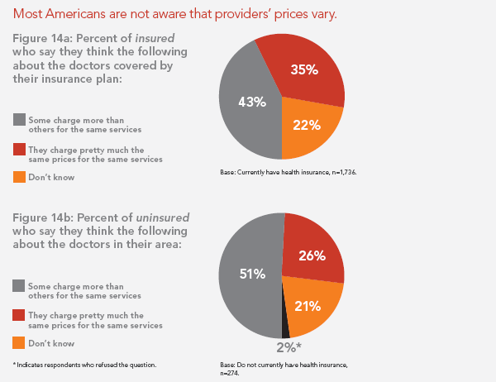

From Public Agenda
http://www.publicagenda.org/pages/how-much-will-it-cost

