Topic: _________________________________________________________________________________________

Category | Facts/Ideas

MODEL
Topic: Female Genital Mutilation

Category | Facts/Ideas
Define FGM | 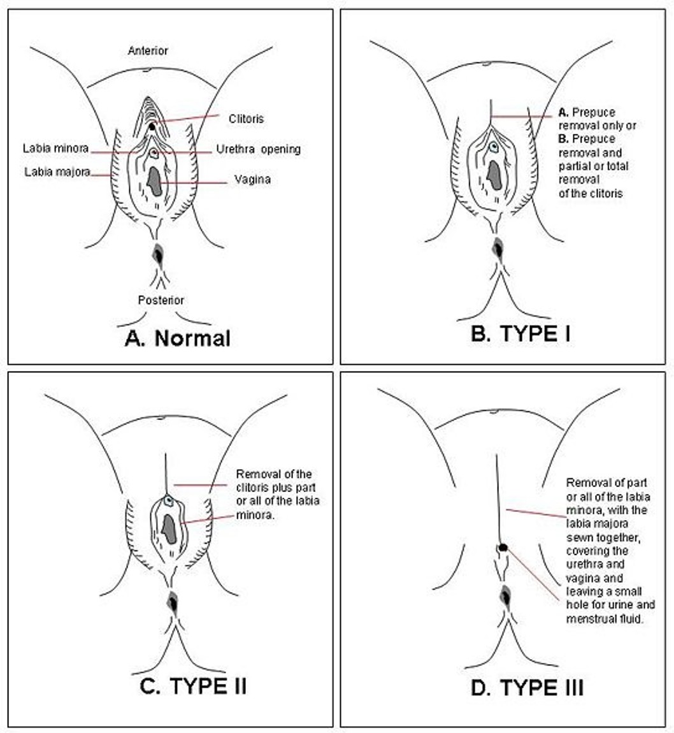  - cutting off outer female genitals (clitoris, labia)  - Goal: no female sexual pleasure
Facts | - between 100 and 140 million girls and women have experienced some form of FGM  - Most younger than 12 years old  - occurs in many countries in Africa, Indonesia, Malaysia, Yemen, Oman, United Arab Emirates, India, and Pakistan.  - Somalia = 98%
Why? | - Sociological - right of passage into womanhood, to “fit in”  - Hygienic - belief female genitalia are dirty  - Sexual - stops female sexuality  - Health - belief it helps child survival and fertility  - Religious - Some think that FGM is a religious requirement  - Socio-economic – needed for marriage (bride is worth more $)
Effects on Girls | - problems with urination and menstruation leading to infections  - chronic pain  - scarred tissues  - infertility  - painful complications with childbirth.
Solutions | - change laws  - education on danger

