GERMANY CHINA

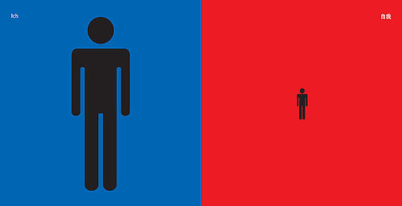

Size of the individual’s ego

GERMANY CHINA

The boss

GERMANY CHINA

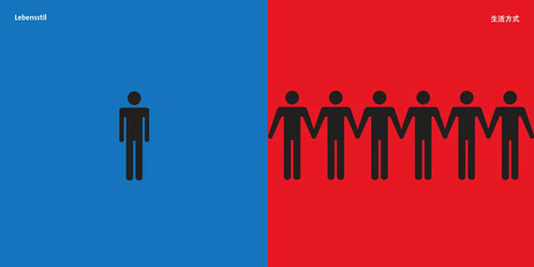

Lifestyle: Independent vs. Dependent

GERMANY CHINA

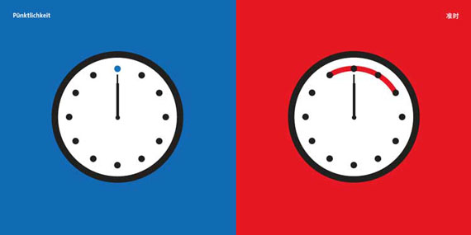

Attitude towards punctuality

GERMANY CHINA

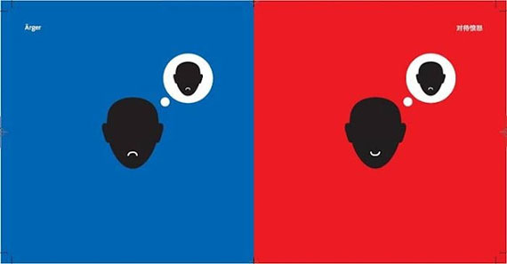

Anger

GERMANY CHINA

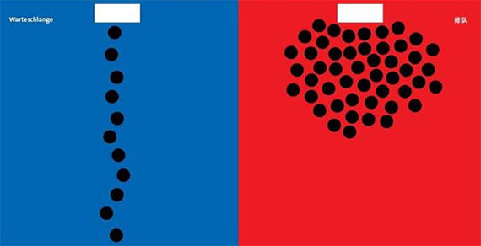

How to stand in line

GERMANY CHINA

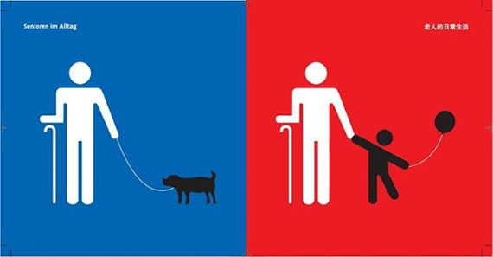

Elderly in day-to-day life

