Understanding Bias
Connections: _____________
Context: _____________

VOCABULARY
bias (noun) prejudice in favor of or against one thing, person, or group compared
with another, usually in a way considered to be unfair, one-sided

objective (adjective) not influenced by personal feelings or opinions in
considering and representing facts

Directions: Look at each of the pictures of President Obama. For each picture, identify what the photographer or artist is trying to make you think about Obama. Then, explain what it is about the picture that is making you feel that way.

PHOTO 1
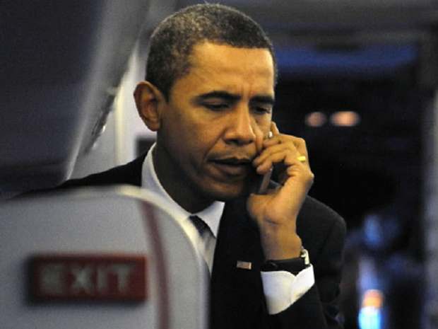
This picture makes me think President Obama is _________________________________________________________
because _______________________________________________ _________________________________________________________

PHOTO 2
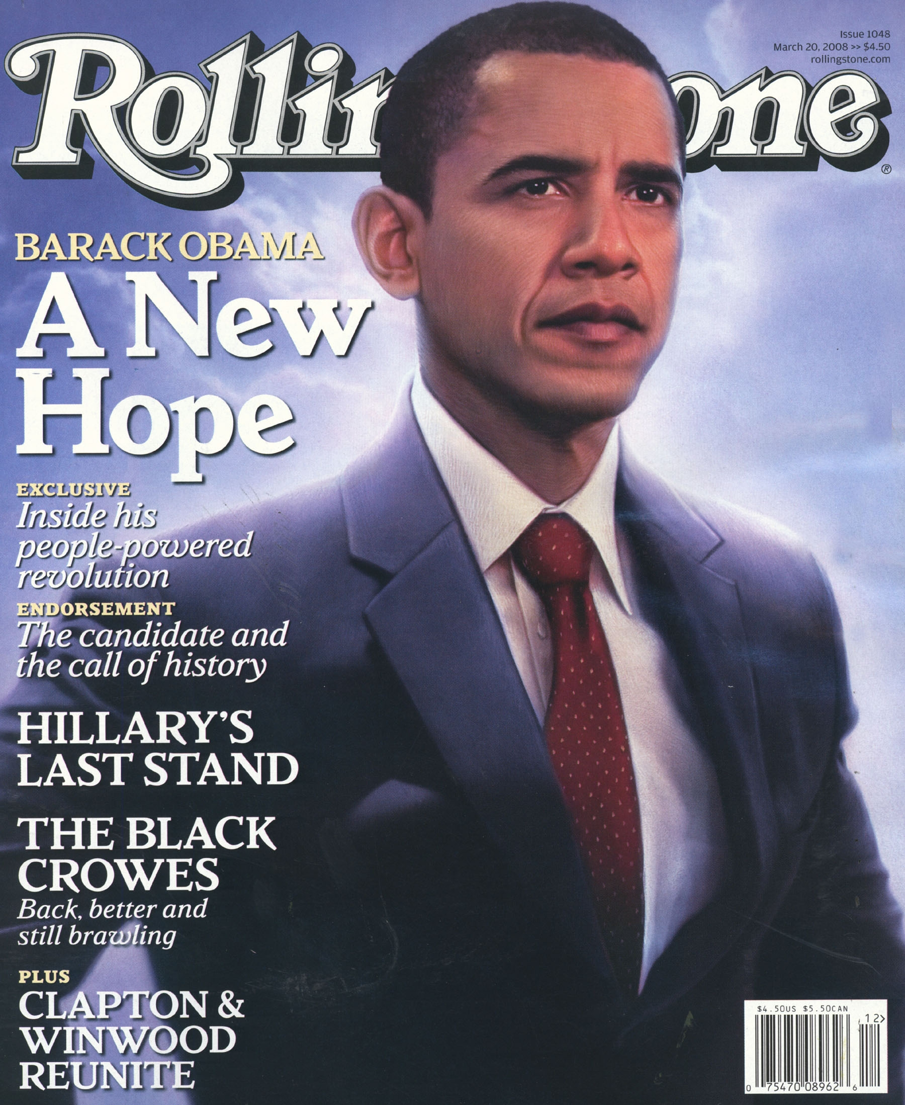
This picture makes me think President Obama is _________________________________________________________
because _______________________________________________ _________________________________________________________

PHOTO 3
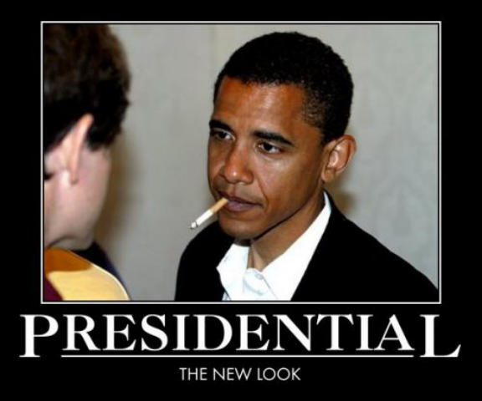
This picture makes me think President Obama is _________________________________________________________
because _______________________________________________ _________________________________________________________

PHOTO 4
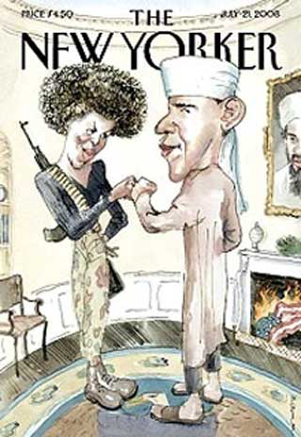
This picture makes me think President Obama is _________________________________________________________
because _______________________________________________ _________________________________________________________

QUESTIONS:

- What was the MOST biased image? Why is it biased?

- What was the LEAST biased image? Why is it less biased?

- Why is it important to find out an author’s bias?

