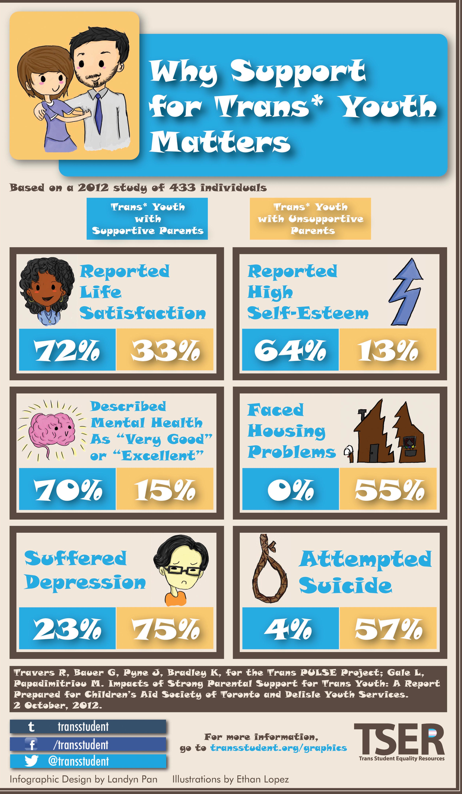

QUESTIONS:

- Why is it important to be a supportive parent to a transgendered child?

- How has today’s lesson and/or this data changed your beliefs about transgendered people?

Connections: __________
Context: __________

QUESTIONS:

- Why is it important to be a supportive parent to a transgendered child?

- How has today’s lesson and/or this data changed your beliefs about transgendered people?

Connections: __________
Context: __________

The trans-everything CEO
By Lisa Miller
New York Magazine

Only about 5 percent of the companies in the Fortune 500 are run by women...On a recent list of America's highest-paid CEOs, only 11 were women, and their median pay was $1.6 million less than their male peers...the highest paid female CEO in America...is Martine Rothblatt...What sets Rothblatt apart from the other women on the list is that she...was born male.

...Martine is transgender...which makes her an even rarer species in the corporate jungle than a female CEO.

...What she prefers to be called is "Martine." To her four young grandchildren she is "Grand Martine." Bina Aspen, the woman who married Martine 33 years ago, when Martine was a man, and remains her devoted wife, calls herself not straight or gay but "Martine-sexual" - as in the only person she wants to have sex with is Martine...At home, they call [Martine] "Dad."

...Martine prefers not to limit herself to available words: She's suggested using "Pn.," for "person" in place of "Mr." and "Mrs.," and "spice" to mean husband or wife." But "trans" is a prefix she likes a lot, for it contains her self-image as an explorer who crosses barriers into strange new lands.

Respond to this reading with
one question OR one comment.

The trans-everything CEO
By Lisa Miller
New York Magazine

Only about 5 percent of the companies in the Fortune 500 are run by women...On a recent list of America's highest-paid CEOs, only 11 were women, and their median pay was $1.6 million less than their male peers...the highest paid female CEO in America...is Martine Rothblatt...What sets Rothblatt apart from the other women on the list is that she...was born male.

...Martine is transgender...which makes her an even rarer species in the corporate jungle than a female CEO.

...What she prefers to be called is "Martine." To her four young grandchildren she is "Grand Martine." Bina Aspen, the woman who married Martine 33 years ago, when Martine was a man, and remains her devoted wife, calls herself not straight or gay but "Martine-sexual" - as in the only person she wants to have sex with is Martine...At home, they call [Martine] "Dad."

...Martine prefers not to limit herself to available words: She's suggested using "Pn.," for "person" in place of "Mr." and "Mrs.," and "spice" to mean husband or wife." But "trans" is a prefix she likes a lot, for it contains her self-image as an explorer who crosses barriers into strange new lands.

Respond to this reading with
one question OR one comment.

