DO NOW: Write 1 comment OR 1 question. Then, determine the main idea as a group.

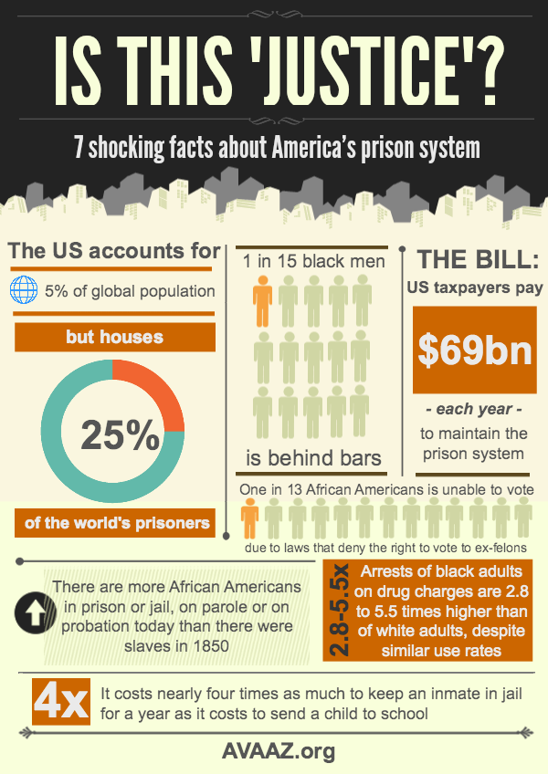

 | INDIVIDUAL or SYSTEMIC racism?  Why? | Possible Effects | Connections  (to anything else we’ve studied?)
Don’t You Hate it When…the Cashier Starts Following You
Subconscious Racial Bias in Children
A Conversation
About Race
Being Muslim
Post-9/11

