Michael Brown Shooting: A Timeline Of The Fallout In Ferguson

by nadeska alexis 8/13/2014 mtv.com

On August 9, 18-year-old black teen, Michael Brown, was shot and killed by white police officer, Darren Wilson, in the Ferguson suburb of St. Louis, Missouri. Over three months later, after nationwide outcry and protests, a Ferguson grand jury decided not to indict Wilson in the shooting.

Who is Michael Brown and what happened to him?
Michael Brown, an 18-year-old from Ferguson, was shot and killed by officer Darren Wilson on Saturday, August 9, while walking to visit his grandmother. Brown was unarmed at the time. According to his mother, Lesley McSpadden, the Normandy High School graduate was set to begin college, just two days after his death.

Why was he shot?
St. Louis County Police Chief Jon Belmar said there was a physical confrontation between Brown, the police officer who shot him, and Brown’s friend Dorian Johnson. They claim that Brown pushed the officer into his squad car and attempted to grab his gun, before shots were fired.

How did the community react to the shooting?
There were immediate protests in St. Louis following the shooting. Residents [gathered] around the site of Brown’s death, and at the Ferguson police headquarters with arms raised in the air chanting, “Don’t shoot,” “I’m Michael Brown,” “No justice, no peace” and “killer cops have got to go.” At one point, protests turned into looting and a [store] was set on fire. A SWAT team descended on the city armed with tear gas to disperse the crowds and the environment became temporarily hostile.

Was officer Darren Wilson ever arrested?
Despite repeated calls for Darren Wilson’s arrest, that never happened. After his identity was revealed, he was only placed on paid administrative leave.

What did Michael Brown’s autopsy results determine?
Autopsy results have concluded that Michael Brown was shot at least six times (in the hand, head, chest, and arms).

Will officer Darren Wilson be put on trial for the shooting?
On Monday night, November 24, [it was] announced that the grand jury [decided] the officer would not be arrested or put on trial for the shooting. Mass protests across the U.S. immediately followed the announcement.

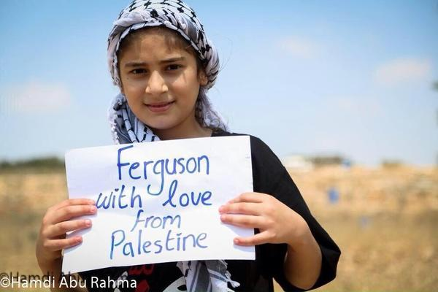
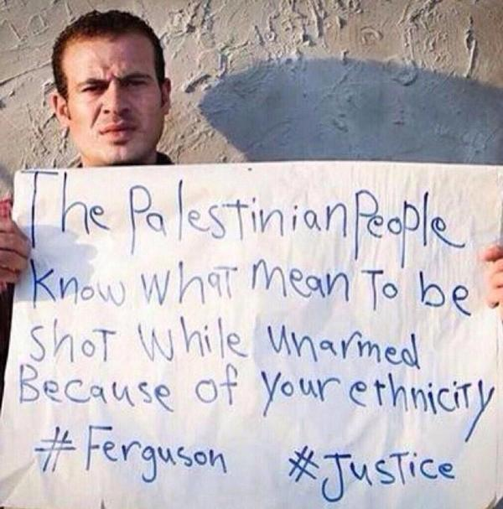

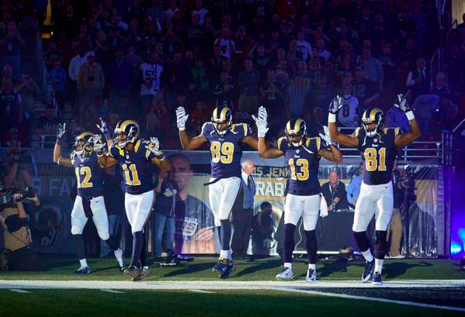

“Hands Up, Don’t Shoot” – St. Louis Rams

