Three Atlanta Men Rape, Burn and Shoot A Woman Who
Beats Them In A Freestyle Rap Battle

By Aya de Leon October 9, 2014 xojane.com
Lynching: to kill by hanging, without a trial; racist practice mostly in the South between the late 1700’s – 1960’s 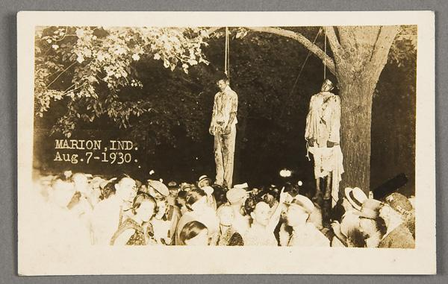
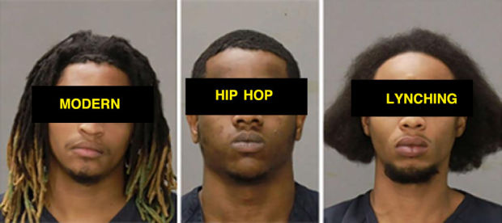

As a hip hop artist, I was always afraid to freestyle battle against men…when artists battle, they often go for blood, [trying to] humiliate their opponent.

I was scared to face off with men because they could always pull the misogyny card, [call me names,] and tell the audience, in clever rhyming detail, what they would do to me sexually…

But some women can do exactly that. A 36-year-old black woman took on three young Atlanta rappers at a house party on New Year’s Eve, 2014. According to…Rolling Out, “During the freestyle battle she matched all three men, rhyme per rhyme, topping them each time.” But these men were not to be [beat]. In response, they [took] her at gunpoint, took her to a vacant lot, gang-raped her, doused her with gasoline, set her body on fire, shot her while she was burning, and left her to die…

[The attack] only received limited media coverage…

I claim this attack was a lynching. Historically in the U.S., lynchings have been primarily understood as Southern white men targeting black men. But black women were lynched as well.

…Lynchings frequently included torture, hanging, burning, desecration, and sexual violence. In cases with female targets, white attackers sexually assaulted them. With male targets they would sometimes cut off their genitals.

White attackers often justified their violence as necessary to protect white women from black men as sexual threats. In the famous Civil Rights Era case of fourteen-year-old Emmett Till, he was visiting Mississippi from Chicago in 1955, “when he reportedly flirted with a white cashier at a grocery store.” Several days later, two white men kidnapped Till, tortured and shot him. The men were tried for murder, but an all-white, male jury [found them not guilty]. Till's murder had an open casket funeral revealing the brutality that he had suffered...
This…[was an excuse to kill]…black people who were an economic threat to…white businesses. Lynching was about keeping Southern black people in their place…

…I claim these Atlanta rappers’ violence as a lynching because it follows the established pattern of violence: abduction, removal to an isolated location, dehumanizing brutality, sexual assault, shooting and burning. They were only missing the final insult -- not possible today -- stringing the body up on a tree and having a family picnic on the scenic grass below.

…The fact that black people were brutalized in this way is incredibly painful. The fact that black people would treat each other this way is even more painful…

Like racial lynching from the Jim Crow era, these rappers’ vicious attack on this woman reveals a…truth about misogyny in rap culture…this act reveals how the…sexual objectification of [black women in hip hop] is [about] the use of sex as a weapon to maintain male domination. [Women] are to be mute objects in hip hop.

According to hip hop artist Coco Peila, when women [can rap well], the industry makes it clear [we must make] X-rated material, and…compete with other women for male approval…we must never…compete directly with male rappers…

…The white-dominated music industry and sexist black male artists and producers leaves little room for diversity of mainstream women rappers…

Hip hop began in the ’70s, as a movement of low-income young black and brown people’s expression. In hip hop’s beginnings there was sexism, but also…possibilities and strong resistance to racism. Today, rap music has become a site for [sharing] values of materialism, misogyny and brutality, for the profit and amusement of a white-dominated recording industry. Like the postcards of lynchings that were photographed, copied, and distributed, rap music has become a [modern] form of black self-hatred as entertainment.

…I grieve for this black woman rapper who believed in herself and her rap skills, who didn’t let rap misogyny tell her what her place was. She had thick enough skin to face these men on a freestyle battlefield [and to] survive their [attack]…[She] “was discovered and rushed to a local hospital, barely alive.”

…“She may never walk again [or use] her left arm…She was in a coma for three weeks. They had to remove part of her lower intestines.” In a recent update…“she has been released from the hospital and at this time she is doing relatively well” considering the extent of her injuries…

However, even if these men haven’t extinguished her life, they have extinguished her voice. And left her story, like a body hanging from a tree, as a [warning to] …women in hip hop that we need to know our place.

