Research Shows…

1) Boys do watch girls and boys, and will watch (and read about) girl leads.

2) Counter-stereotype images don’t turn children off (For example, kids will watch movies about girls that are tough and strong.)

3) TV shows make 80% of their money from selling clothes and toys about the characters…Boys and girls will only see these toys if they are in the “boy” or “girl” section. Books are separated by age, but clothes and toys are separated by gender.

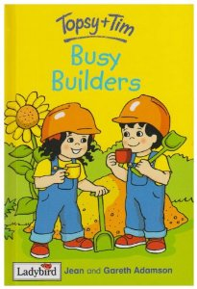
Examples
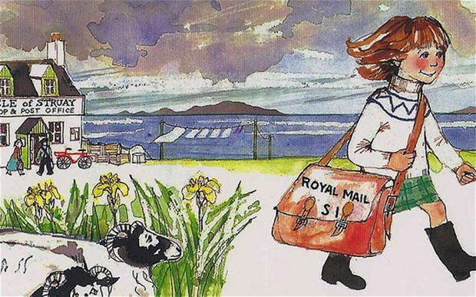

Kay Benbow makes shows with female main characters like Katie Morag and Topsy and Tim.

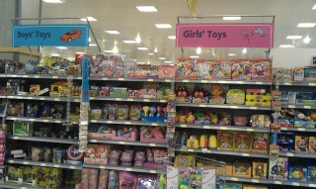
The way most toys are normally shown, the carpeting in the shop, the toys on the nearby shelves and the colors of the shelves all give children a message that some toys aren’t for them.

However, Let Toys Be Toys is a company that makes toys NOT for “boys” or “girls,” just for kids! Like Beth Cox said, “Every time we create for boys and girls we create difference. Create for children.”

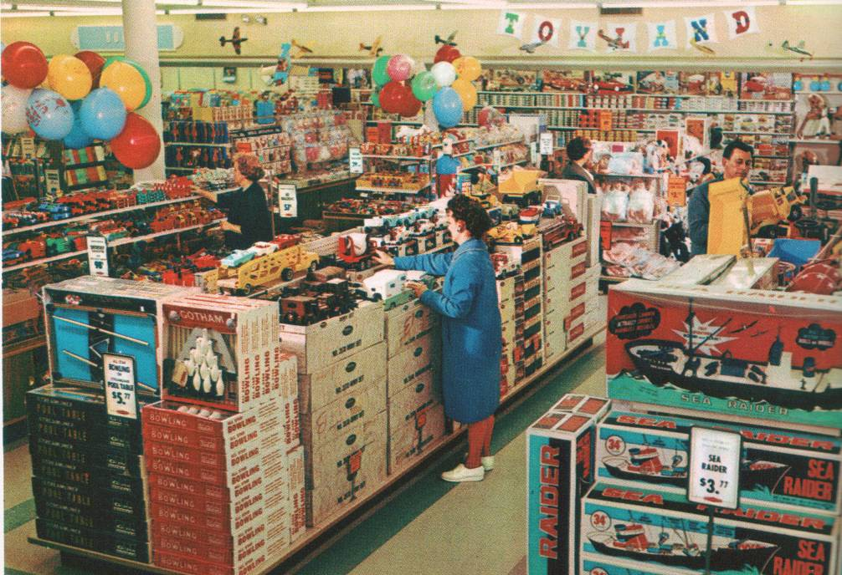

Woolworths was a company who always grouped all products by brand, and never by gender, but they went out of business.

