#YesAllWomen
By Phil Plait
On Friday, May 23, 2014, a man killed six people (and possibly himself). The manifesto he left behind stated he did it because women wouldn’t sleep with him…
The murderer was active on men’s rights forums, where women are highly objectified, to say the very least. They are seen as nonhuman by many such groups, and at the very least lesser than men—sometimes nothing more than targets or things to acquire…
Of course, these loathsome people represent a very small percentage of men out there. Over the weekend, as the discussion across Twitter turned to these horrible events, a lot of men started tweeting this, saying “not all men are like that.” It’s not an unexpected response. However, it’s also not a helpful one.

Why is it not helpful to say “not all men are like that”? For lots of reasons. For one, women know this. They already know not every man is a rapist, or a murderer, or violent. They don’t need you to tell them.

Second, it’s defensive. When people are defensive, they aren’t listening to the other person; they’re busy thinking of ways to defend themselves. I watched this happen on Twitter, over and again.

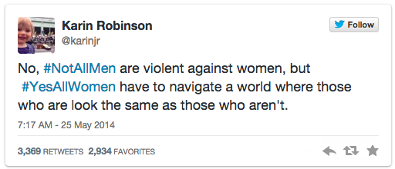

Third, the people saying it aren’t furthering the conversation, they’re sidetracking it. The discussion isn’t about the men who aren’t a problem. Instead of being defensive and distracting from the topic at hand, try staying quiet for a while and actually listening to what the thousands upon thousands of women discussing this are saying.

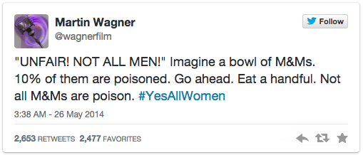

Fourth—and this is important, so listen carefully—when a woman is walking down the street, or on a blind date, or, yes, in an elevator alone, she doesn’t know which group you’re in. You might be the potential best guy ever…but there’s no way for her to know that. A fraction of men out there are most definitely not in that group…

This is the reality women deal with all the time.

…over the weekend, the hashtag #YesAllWomen started. It was a place for women to counter the #NotAllMen distraction, and to state clearly and concisely what they actually and for real have to deal with. All the time.

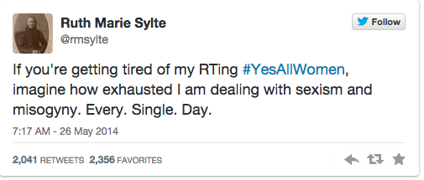

Those tweets say it far better than I ever could, for many reasons. The most important is because I’m a man, so I haven’t lived through what they have. I can’t possibly understand it at the level they do, no matter how deeply disturbed I am by the situation and how sympathetic I may be to what they’ve gone through.
This is not a failing, or an admission of weakness. It’s a simple truth. I’m a white, middle-class male, so I can understand intellectually what black people have undergone, or what women have dealt with, or what Japanese-Americans suffered in America in World War II. As someone raised Jewish, I may have more of an understanding for what an oppressed people have withstood in general, but I’ve never really been oppressed myself. That puts me in a position of—yes—privilege.

All that means is that I can only speak from my own point of view, and try to understand others as best I can. [It took me a long time to] see how I was participating in…everyday sexism. It was like air, all around me…I didn’t see it, even when I was in it and a part of it.

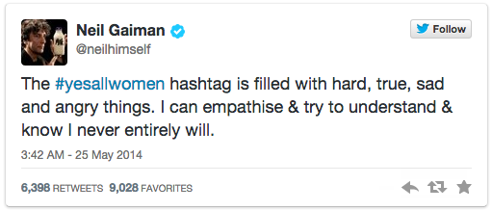

Even though [many men] may not be the direct problem, we still participate in the cultural problem. If we’re quiet, we’re part of the problem. If we don’t listen, if we don’t help, if we let things slide for whatever reason, then we’re part of the problem, too.

We men need to do better.

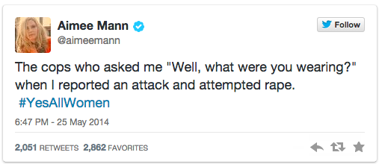

Part of this problem is the mislaying of blame, and the misdirection of what to do. When it comes to legal action, to the enforcement of rules, to societal pressure, it all comes down on the women and not the men.

Which leads me to the best tweet using this hashtag that a man put up.

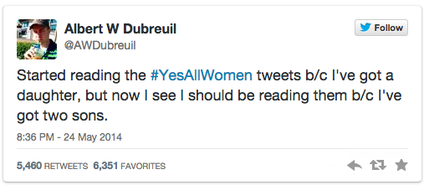

That is exactly right. We need to change the way we talk to boys in our culture as well as change the way we treat women.

And one final word on this. As a man, having written this post I expect there will be comments insulting me, comments questioning my manhood (whatever twisted definition those people have of such a thing, if it even exists), and so on.

But you know what there won’t be? People threatening to stalk me and rape me and kill me for having the audacity to say that women are people, and that we should be listening to them instead of telling them how to feel. Yet that is precisely what every woman on the Internet would face if she were to write this.

And that is, sadly, why we so very much need the #YesAllWomen hashtag.

Gender Studies- Ms. Lindsay - Agenda

Aim: Why is it not helpful to react defensively when our privilege is challenged?

Do Now: Read the following tweet. Then, explain what it means. Why do you think this tweet use the hashtag #YesAllWomen? 10 mins

"'I have a boyfriend' is the easiest way to get a man to leave you alone. Because he respects another man more than you. #yesallwomen"

Share Out: Students share answers with class. 5 mins

Introduce Activity: We will read an article as a class about a specific example of men responding defensively to women talking about the difficulties of being a woman in this society. 5 mins

In Groups, Students Read: Students can determine whether they want to read independently and then discuss as a group, or take turns reading aloud within the group and then discussing what they read. 20 mins

Questions (Each student must answer these on their own paper, but can work as a group to determine the answers.) 15 mins

- What does the word privilege mean? What is one example of privilege we’ve discussed in class?

- What is the main idea of this article? What evidence supports this?

- How does this article connect to the response to the shooting of Michael Brown in Ferguson, Missouri?

- What are some ways males can help make the world a better place for females? (from the text, from previous classes, or from your imagination)

- What did the last tweet mean? (see below)

Share Out: Students share answers with whole class 10 mins

