Name: _______________________________
Independent Work: Self-Regulation Questions

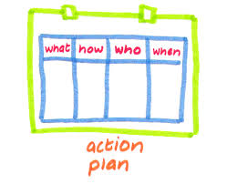
- PLAN

What do I want to learn?

What do I need to know or do to get this done?

How will I work?

- REFLECT

Did I accomplish everything I had hoped to?

Did I do well? Did I do poorly? Why?

What worked? What did not work?

What should I do differently next time?

Date: ______________________
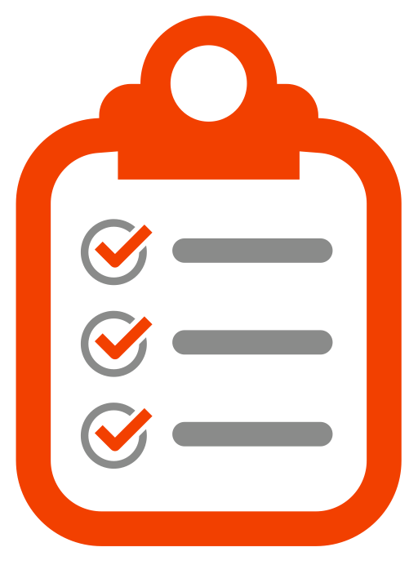
- MONITOR

Do I understand everything?

Am I accomplishing what I hoped to?

Am I being distracted?

Is this taking more time than I thought?

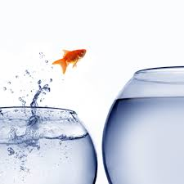
- CONTROL

I don’t think I’m getting this…

What should I do differently?

How can I encourage myself to get this done?

